Ruan Cupido
VARSITY COLLEGE | ST10450618
INSY7213

Table of Contents
Question 1 2
Question 2 4
Question 3 5
Question 4 7
Question 5 8
Question 6 10
Question 7 12
Question 8 15
Question 9……………………………………………………………………………………………………………………………………….16
Q 9.1 16
Q 9.2 16
Question 10 18
1. Introduction 18
2. Ensuring Confidentiality 18
2.1. Database Access Control 18
2.2. Data Encryption 18
2.3. Secure Authentication and Password Policies 19
2.4. Data Masking 19
3. Ensuring Integrity 19
3.1. Constraints and Triggers 19
3.2. Auditing and Logging 20
3.3. Backup Validation and Hashing 20
3.4. Transaction Management 20
4. Ensuring Availability 21
4.1. Backup and Recovery 21
4.2. High Availability Solutions 21
4.3. Monitoring and Maintenance 21
5. Conclusion 21
References 22
Disclosure of AI Usage in my Assessment 24

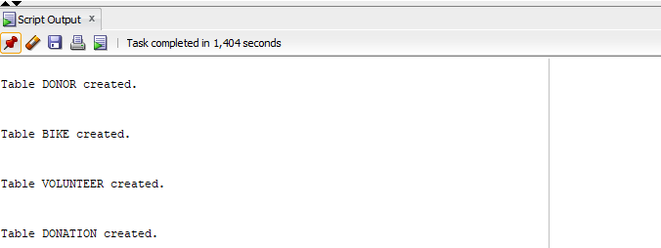
Question 1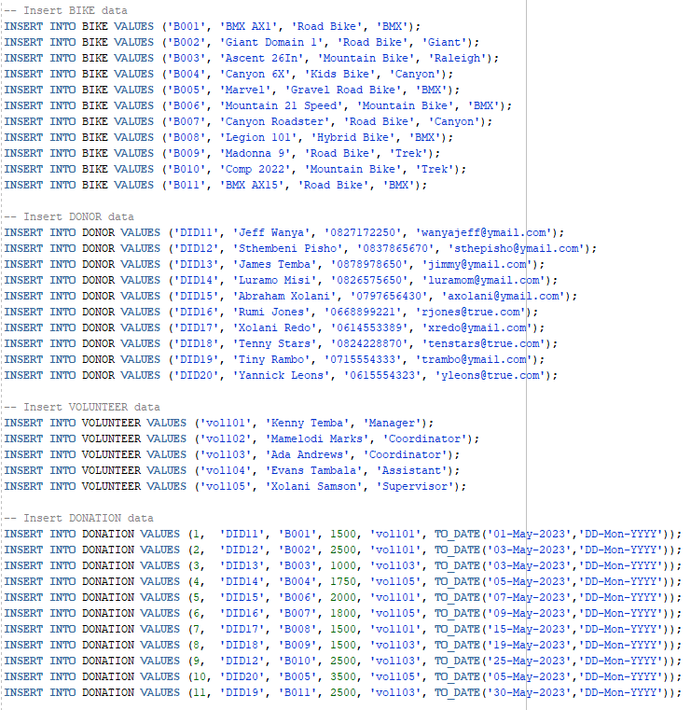

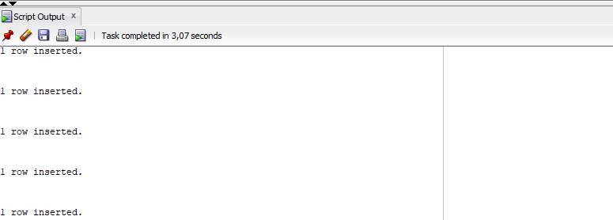

Question 2
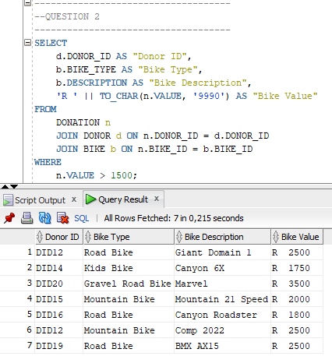

Question 3
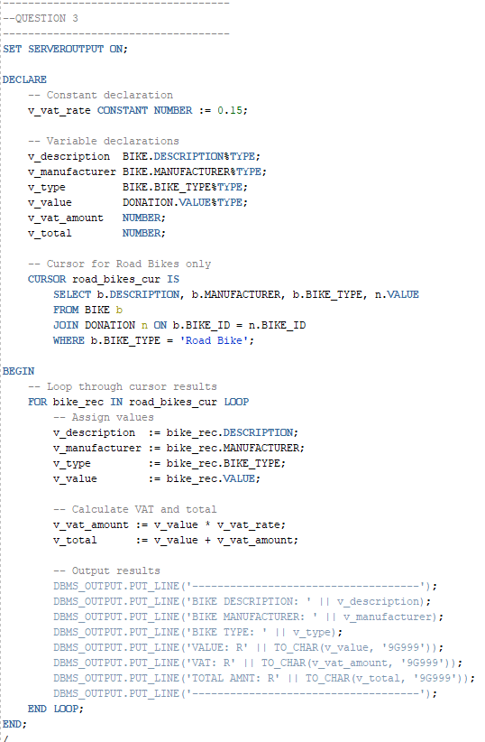
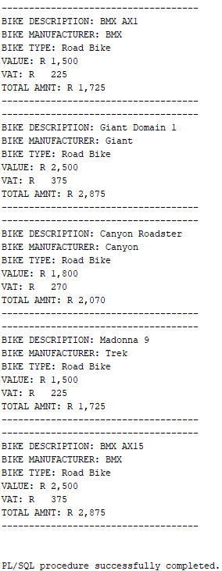

Question 4
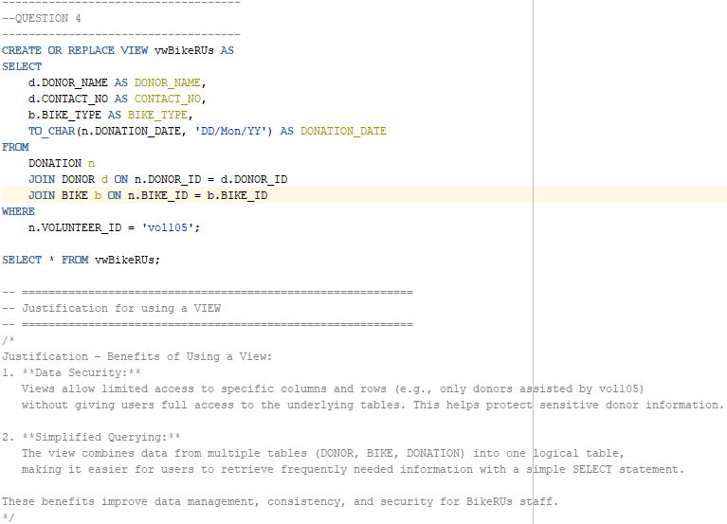
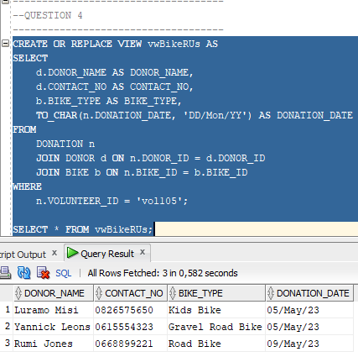

Question 5
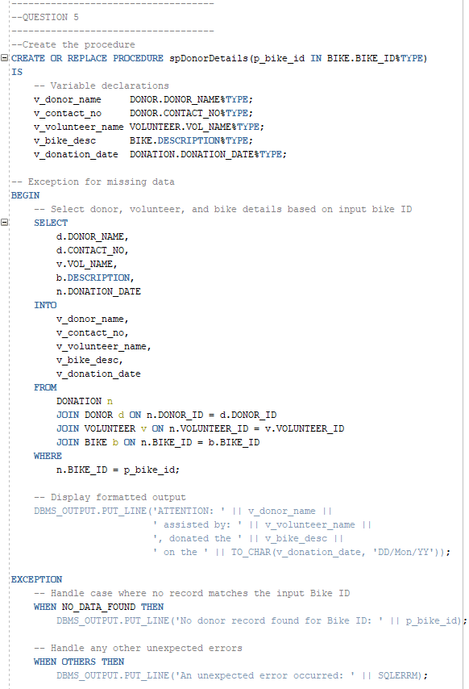

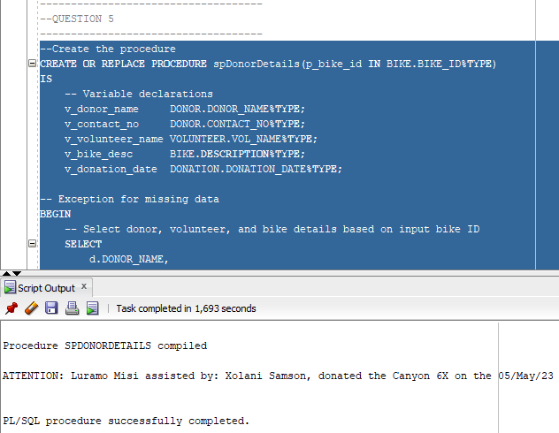

Question 6
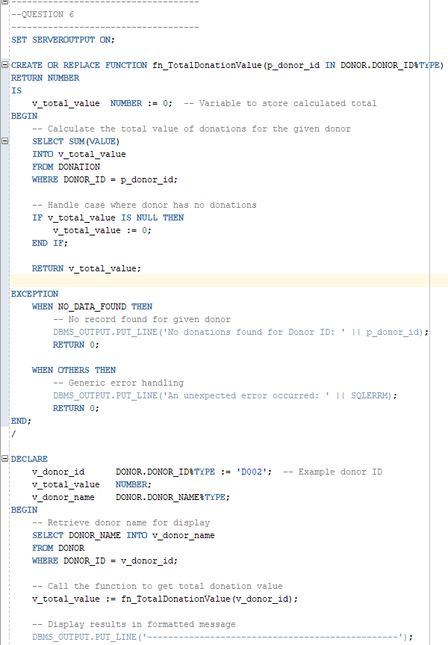
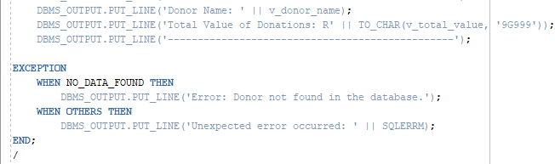
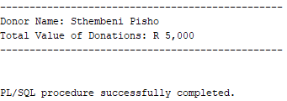

Question 7
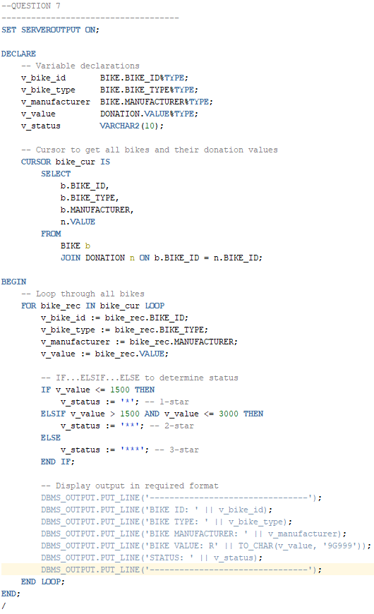
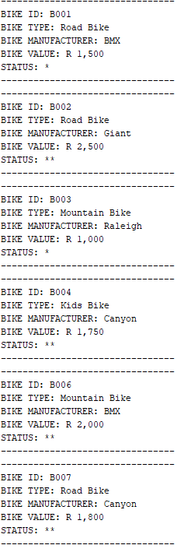
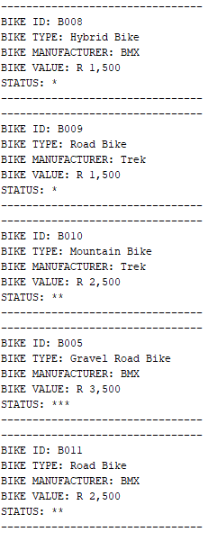

Question 8
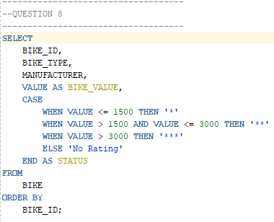
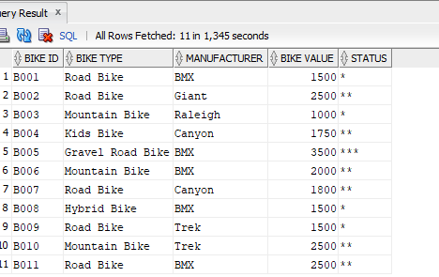
Question 9
I used LiveSQL to generate and test my SQL code for q9 since because my SQL Developer user was under SYS, it could not create a trigger so I used LiveSQL to demonstrate that my code is working.

Q 9.1
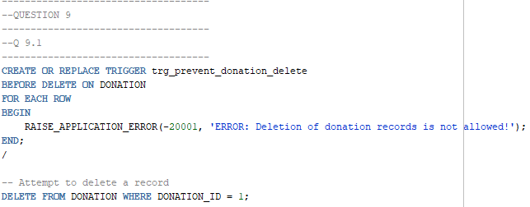
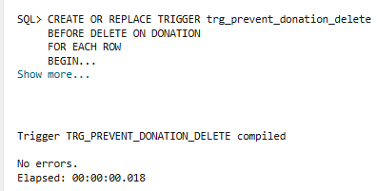

Q 9.2
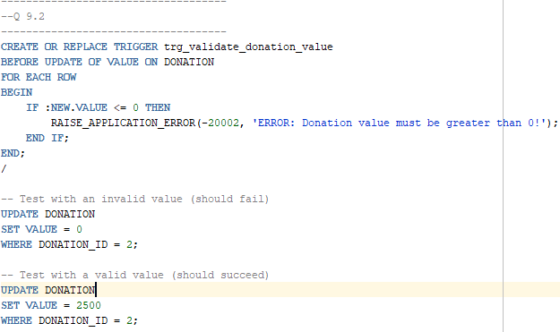
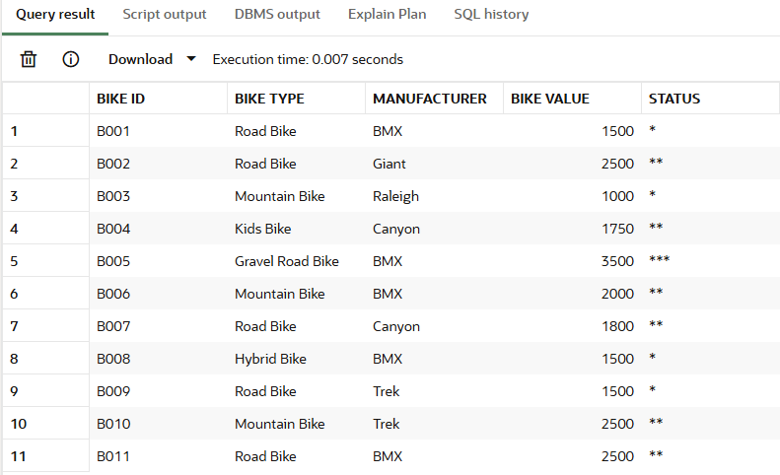

Question 10
Technical Report on Ensuring Confidentiality, Integrity, and Availability of Data at BikesRUs

1. Introduction
In the current digital environment, safeguarding organizational information has become an essential aspect of sustainable business practices. For BikesRUs, a nonprofit organization that oversees donations, bicycles, contributors, and volunteers, securing data is vital for sustaining trust, ensuring compliance, and maintaining operational continuity. This document presents a comprehensive technical strategy to uphold the confidentiality, integrity, and availability (CIA) of the organization’s data. It elaborates on how these principles can be applied through a mix of secure technologies, database management methods, and administrative controls, backed by relevant tools and sample code for BikesRUs’ Oracle database context.

2. Ensuring Confidentiality
Maintaining confidentiality is essential for preventing illicit access to sensitive information like donor information, volunteer records, and details of donations (Kidd, 2024). Leaking such information can lead to breaches of privacy and harm to one's reputation. To uphold confidentiality, it is necessary to implement various technical and procedural protections (Kidd, 2024).

2.1. Database Access Control
Establishing role-based access control (RBAC) in Oracle guarantees that only permitted users can carry out particular tasks (Anna, 2024).
For instance:
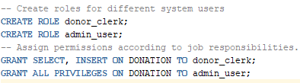
This guarantees that clerks can input donation information but cannot erase or change current records, whereas administrators have complete access (Anna, 2024).

2.2. Data Encryption
Encryption safeguards data whether it is stored or being transmitted (Microsoft, 2025). Oracle Transparent Data Encryption (TDE) is capable of encrypting sensitive information, including donor contact numbers and email addresses (Microsoft, 2025).
This guarantees that even if the database files are directly accessed, the data stays encrypted (Microsoft, 2025). For securing data in transit, BikesRUs must mandate SSL/TLS connections for accessing the database remotely, safeguarding against the interception of credentials or queries (Microsoft, 2025).

2.3. Secure Authentication and Password Policies
Robust authentication methods are essential (AI2sql, 2025). Oracle provides password profiles that mandate rules regarding length, complexity, and expiration (AI2sql, 2025):
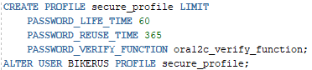
Moreover, enforcing Multi-Factor Authentication (MFA) for administrators, such as through the integration with Oracle Identity Management (OIM) or Azure Active Directory, provides an additional level of security (AI2sql, 2025).

2.4. Data Masking
To safeguard personal information in testing or training settings, BikesRUs ought to utilize Oracle Data Masking and Subsetting (Microsoft, 2025). This guarantees that sensitive data like donor names or contact information is anonymized while preserving realistic formats (Microsoft, 2025).

3. Ensuring Integrity
Integrity involves preserving the accuracy and consistency of data at all stages of its lifecycle. Any corruption or unauthorized changes to data could distort the values of donations or donor records, compromising trust and accountability.

3.1. Constraints and Triggers
Integrity starts with the design of the database schema (w3schools, 2025). Implementing primary keys, foreign keys, and check constraints guarantees referential integrity (w3schools, 2025).
For example:
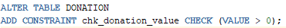
Furthermore, triggers can stop invalid updates or deletions, as shown in previous questions, making sure that no donation records are deleted or wrongly changed (w3schools, 2025).

3.2. Auditing and Logging
Oracle Database Auditing (DBA_AUDIT_TRAIL) logs all modifications made to the database (Toorpu, 2025). Activating auditing assists in identifying unauthorized alterations to data (Toorpu, 2025).
Administrators have the ability to regularly examine audit logs to maintain accountability (Toorpu, 2025).

3.3. Backup Validation and Hashing
To ensure the integrity of data that has been transferred or backed up, cryptographic hashing methods (such as SHA-256) can be employed for verification (Gupta, 2019).
Here's a straightforward example in Python to check the integrity of a backup:
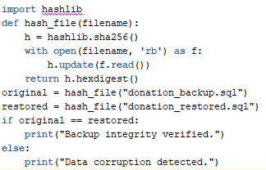
This guarantees that the backup data corresponds to the original source without any alterations (Gupta, 2019).

3.4. Transaction Management
Implementing COMMIT and ROLLBACK commands in Oracle guarantees data integrity during transaction processes (geeksforgeeks, 2025). In the event that an error arises while processing a donation, the transaction can be reverted to uphold precision (geeksforgeeks, 2025).
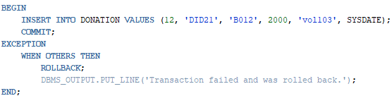

4. Ensuring Availability
Uptime ensures that authorized users can consistently access data whenever necessary. BikesRUs needs to prepare for hardware malfunctions, network interruptions, and system congestion.

4.1. Backup and Recovery
Consistent backups of the database with Oracle Recovery Manager (RMAN) guarantee that data can be recovered in case of damage or loss (w3schools, 2025).
Sample command:

Cloud-based backups can be stored on either Oracle Cloud Infrastructure (OCI) or Azure Blob Storage for added redundancy (w3schools, 2025).

4.2. High Availability Solutions
BikesRUs has the option to utilize Oracle Data Guard or Real Application Clusters (RAC) to ensure continuous database availability (PaperCut, 2025). These solutions copy the database to backup servers and automatically switch over during system outages (PaperCut, 2025).

4.3. Monitoring and Maintenance
Solutions like Oracle Enterprise Manager or open-source options such as Zabbix are capable of overseeing performance, storage, and system health in real-time, notifying administrators ahead of potential failures (AdvancedTech, 2025).

5. Conclusion
The CIA triad, Confidentiality, Integrity, and Availability, serves as the cornerstone of data security for BikesRUs. By utilizing encryption, implementing role-based access control, and enforcing password policies, confidentiality can be maintained. Data integrity is strengthened through the use of database constraints, auditing processes, and transaction management, while availability is ensured by comprehensive backup plans and failover solutions. Collectively, these strategies create a strong security framework that fosters donor trust, adheres to data protection regulations, and supports the organization's long-term reliability.
With effective planning and ongoing monitoring, BikesRUs can reliably protect its important data assets from both accidental and intentional threats.

References
AdvancedTech, 2025. What is Condition-Based Monitoring and Maintenance?. [Online]
Available at: https://www.advancedtech.com/blog/condition-based-monitoring-and-maintenance/
[Accessed 2025].
AI2sql, 2025. Secure SQL Authentication — Examples & 2025 Guide. [Online]
Available at: https://ai2sql.io/learn/secure-sql-authentication
[Accessed 2025].
Anna, 2024. Access Controls for Users and Roles in SQL. [Online]
Available at: https://dev.to/anna_p_s/access-controls-for-users-and-roles-in-sql-44b6
[Accessed 2025].
geeksforgeeks, 2025. SQL TRANSACTIONS. [Online]
Available at: https://www.geeksforgeeks.org/sql/sql-transactions/
[Accessed 2025].
Gupta, R., 2019. Validate backups with SQL restore database operations using DBATools. [Online]
Available at: https://www.sqlshack.com/validate-backups-with-sql-restore-database-operations-using-dbatools/#:~:text=Example%204:%20Verify%20backups%20without%20database%20restoration%0A%0AIn,using%20a%20parameter%20%2DVerifyOnly%20in%20Test%2DDbaLastBackup%20command.
[Accessed 2025].
Kidd, C., 2024. What's The CIA Triad? Confidentiality, Integrity, & Availability, Explained. [Online]
Available at: https://www.splunk.com/en_us/blog/learn/cia-triad-confidentiality-integrity-availability.html
[Accessed 2025].
Microsoft, 2025. Dynamic data masking. [Online]
Available at: https://learn.microsoft.com/en-us/sql/relational-databases/security/dynamic-data-masking?view=sql-server-ver17
[Accessed 2025].
Microsoft, 2025. Transparent data encryption (TDE). [Online]
Available at: https://learn.microsoft.com/en-us/sql/relational-databases/security/encryption/transparent-data-encryption?view=sql-server-ver17
[Accessed 2025].
PaperCut, 2025. The ultimate guide to High Availability methods for Microsoft SQL Server. [Online]
Available at: https://www.papercut.com/discover/best-practices/high-availability-methods-for-microsoft-sql-server/
[Accessed 2025].
Toorpu, A., 2025. Auditing SQL Server Database Users, Logins, and Activity: A Comprehensive Guide. [Online]
Available at: https://dev.to/arvind_toorpu/auditing-sql-server-database-users-logins-and-activity-a-comprehensive-guide-4dk4#:~:text=1.,Create%20a%20Session:
[Accessed 2025].
w3schools, 2025. SQL BACKUP DATABASE for SQL Server. [Online]
Available at: https://www.w3schools.com/sql/sql_backup_db.asp
[Accessed 2025].
w3schools, 2025. SQL Constraints. [Online]
Available at: https://www.w3schools.com/sql/sql_constraints.asp
[Accessed 2025].

Disclosure of AI Usage in my Assessment

Section(s) within the assessment in which generative AI was used:
Question 4 and 6
Name of AI tool(s) used:
ChatGPT
Purpose/Intention:
To understand certain topics/concepts and use that understanding to answer the questions.
Date(s) in which generative AI was used:
10 Nov 2025
Conversation Links:
https://chatgpt.com/share/691218b0-3ab4-8011-a18b-77679035446d

